From Spreadsheet
Respondents with highest certainty (5) consistently have highest proportion of yes responses when asked if they would need an additional GDPR consent form across 4 situational certainty questions
- On sheet labeled “Analyse (situationsbedingt Sicherheit)”
- The respondents with answers of 4 or 5 always have the highest proportion of yes responses when compared to respondents with answers from 1-3
  - Sometimes, this is by a small margin. Ex. 2nd question: respondents of 4 and 5 have yes proportions of 0.401826484 and 0.4608695652, while respondents of 1 have yes proportion of 0.4
- However, we may need more testing with bigger sample sizes for extra certainty. For all questions, the groups with certainty of 1 (very high uncertainty) are always less than 30 firms

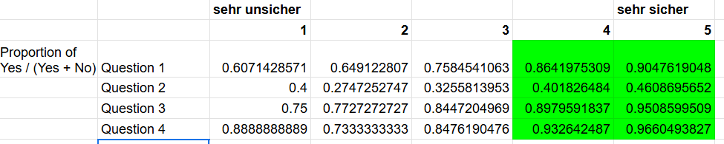

From RStudio
Companies further into GDPR implementation are more likely to show certainty across all 4 situations
- I first took the survey data but removed rows with empty values in these columns:
  - erf_speich, si_speich, erf_intern, si_intern, erf_extunt, si_extunt, erf_forsch, si_forsch
  - This led to 741 observations instead of 1352
- I then created a variable always_high_certainty that was 1 if all of the following variables were 4 or 5. Otherwise it was 0
  - Conditions: Si_speich > 3, Si_intern > 3, Si_extunt > 3, Si_forsch > 3
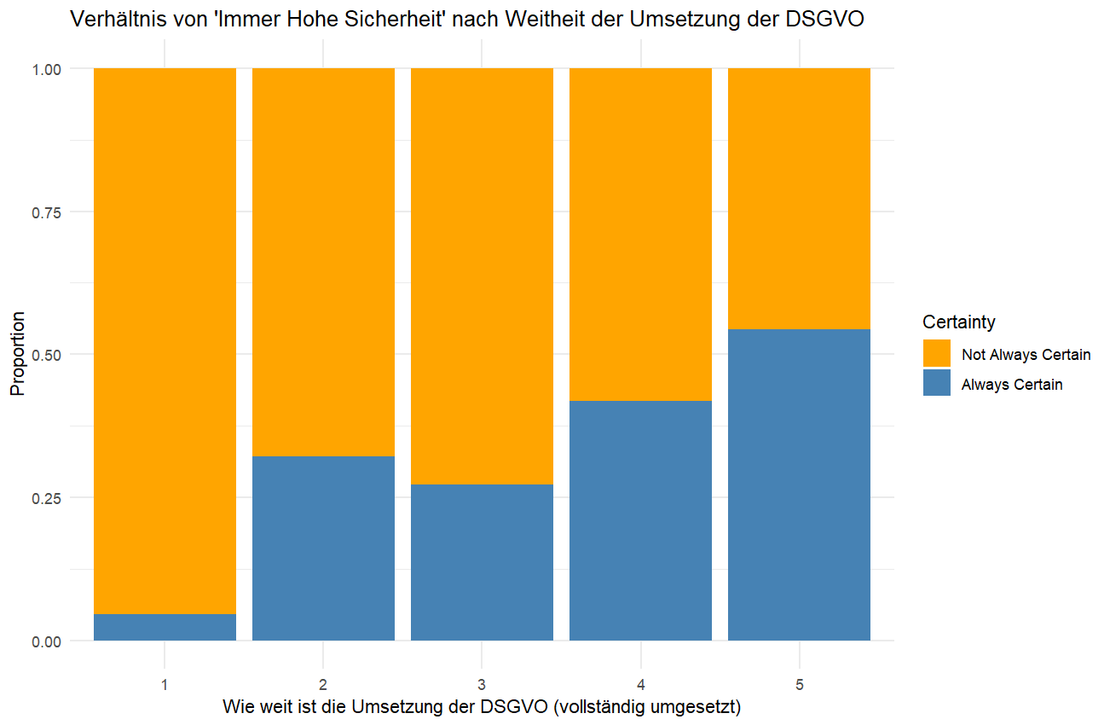
- This relationship is not as strong with always_high_certainty and other variables like kund_dat or pdwichtig

30 July 2025
Sicher_extunt_binary
Model 1: 0.7689 Kund_dat2, kund_dat3, kund_dat5, umheute3, umheute4, umheute5
Model 6: 0.7447 umheute45,

erf_extunt
Model 1: 0.9048 (Warning: glm.fit: fitted probabilities numerically 0 or 1 occurred ) pdwichtig3, umheute4, umheute5, nachegleich, persegesunken, a_ki3, a_ki4,
Model 6: 0.8973 umheute23, umheute45, umsgesunken, persegesunken, a_gefahr45, a_ki23, a_ki45,

Sicher_forsch_binary
Model 1: 0.7311 Kund_dat2, kund_dat3, kund_dat4, kund_dat5, datengm3, datengm5, umheute5, a_aufwand5
Model 6: 0.6903 a_aufwand45

erf_forsch
Model 1: 0.929 everything
Model 6: 0.9199 datengm45, umheute45, a_forsch45

Sicher_intern_binary
Model 1: 0.6873 Intercept, umheute4, umheute5, persgleich, persgesunken
Model 6: 0.6299 umheute45

erf_intern
Model 1: 0.6888 a_vorteil5,
Model 6: 0.6526 nothing

Sicher_speich_binary
Model 1: 0.7266 everything
Model 6: 0.6964 umheute23, umheute45, umsegleich, nachegleich, nachegesunken, a_gefahr23, a_kost23, a_kost45, a_proz45, a_stand45

erf_speich
Model 1: 0.8459 intercept, pdwichtig5, nachgleich, nachegleich, nachegesunken, a_gefahr2, a_aufwand3, a_aufwand4, a_aufwand5, a_kompliz2, a_kompliz5
Model 6: 0.8338 intercept, nachegesunken, a_gefahr23, a_aufwand45

Accuracies for multivar_logistic_models

Report
The goal of this research is to determine what variables or response behavior can be predicted based on firms’ perceptions of certainty and applicability regarding the EU General Data Protection Regulation and vice versa. All R source code is available here.

Much of the preliminary data analysis stage was conducted in a spreadsheet linked here. We first calculate descriptive statistics about each survey response variable, including mean, standard deviation, sample size, median, and 95% confidence intervals. We also create many column charts to find counts and proportions of responses for each survey question. Lastly, we find that as the certainty in each situational question increases, the proportion of “yes” responses to the corresponding situational question tends to increase too. The screenshot below highlights that the proportion of yes responses is highest when firms mark their certainty as 4 or 5, although the trend is not strictly linear from 1 to 5.

We later build multivariable logistic regression models in R to predict binary (yes/no) answers to questions included on the survey linked here. Please note that the survey is in German. Before building any models, empty rows for multiple variables were removed to facilitate the calculation of each model’s accuracy. We began with 1352 observations and built all models off of 662 observations. Many responses were lost because the second half of the survey was conducted separately and not all respondents submitted it.

Models 1 and 6 are designed to determine which firm characteristics gathered from the survey can be used to predict 8 variables:
- sicher_extunt_binary
- erf_extunt
- sicher_forsch_binary
- erf_forsch
- sicher_intern_binary
- erf_intern
- sicher_speich_binary, and
- Erf_speich

The variables beginning with “erf” represent a yes or no response to a question that asks if a firm would require an additional GDPR consent form in a specific situation. For example, erf_forsch would be yes if the firm believes that it would need an additional form in order to forward customer data to a research institution in Germany. The variables beginning with “sicher” represent a response of 4 or 5 when a firm is asked how certain, on a scale of 1 to 5, they are in their response to the corresponding yes or no question. For example, if a company responds that their certainty regarding their response to erf_extunt is just a 3, then sicher_extunt_binary would be 0 in this observation.

We find that the explanatory variables (any variable that has a p-value of less than 0.05 in a regression model) differ for each of the 8 variables above, or for the 4 situations mentioned in the survey. The table below lists the accuracy in predicting each variable with each model and the potential explanatory variables in each regression model.

Variable + Model | Accuracy | Explanatory Variables
sicher_extunt_binary Model 1 | 0.7689 | Kund_dat2, kund_dat3, kund_dat5, umheute3, umheute4, umheute5
sicher_extunt_binary Model 6 | 0.7447 | umheute45
erf_extunt Model 1 | 0.9048 | pdwichtig3, umheute4, umheute5, nachegleich, persegesunken, a_ki3, a_ki4
erf_extunt Model 6 | 0.8973 | umheute23, umheute45, umsgesunken, persegesunken, a_gefahr45, a_ki23, a_ki45
sicher_forsch_binary Model 1 | 0.7311 | Kund_dat2, kund_dat3, kund_dat4, kund_dat5, datengm3, datengm5, umheute5, a_aufwand5
sicher_forsch_binary Model 6 | 0.6903 | a_aufwand45
erf_forsch Model 1 | 0.929 | everything
erf_forsch Model 6 | 0.9199 | datengm45, umheute45, a_forsch45
sicher_intern_binary Model 1 | 0.6873 | Intercept, umheute4, umheute5, persgleich, persgesunken
sicher_intern_binary Model 6 | 0.6299 | umheute45
erf_intern Model 1 | 0.6888 | a_vorteil5
erf_intern Model 6 | 0.6526 | nothing
sicher_speich_binary Model 1 | 0.7266 | everything
sicher_speich_binary Model 6 | 0.6964 | umheute23, umheute45, umsegleich, nachegleich, nachegesunken, a_gefahr23, a_kost23, a_kost45, a_proz45, a_stand45
erf_speich Model 1 | 0.8459 | intercept, pdwichtig5, nachgleich, nachegleich, nachegesunken, a_gefahr2, a_aufwand3, a_aufwand4, a_aufwand5, a_kompliz2, a_kompliz5
erf_speich Model 6 | 0.8338 | intercept, nachegesunken, a_gefahr23, a_aufwand45

In the table below are some of the proportions of specific explanatory variables included. This is important to ensure that an explanatory variable was not flagged simply due to low sample sizes and outliers.

variable | proportion within response group
kund_dat2 | 66 / 662
kund_dat3 | 157 / 662
kund_dat4 | 194 / 662
kund_dat5 | 223 / 662
umheute3 | 116 / 662
umheute4 | 237 / 662
umheute5 | 262 / 662
datengm3 | 149 / 662
datengm5 | 232 / 662
a_aufwand5 | 243 / 662
persgleich | 375 / 662
persgesunken | 147 / 662

Models 2, 3, 4, and 5 are also logistic regression models designed to use the 8 variables mentioned in Models 1 and 6 to predict these 15 variables:
- a_positiv_zustimmung
- a_rsicher_zustimmung
- a_gefahr_zustimmung
- a_aufwand_zustimmung
- a_kompliz_zustimmung
- a_vorteil_zustimmung
- a_vertrau_zustimmung
- a_inno_zustimmung
- a_kost_zustimmung
- a_berat_zustimmung
- a_proz_zustimmung
- a_stand_zustimmung
- a_ki_zustimmung
- a_forsch_zustimmung
- a_nachteil_zustimmung

Each variable above represents a response of 4 or 5 to the corresponding survey question. For example, if a firm responds with a 4 out of 5 when asked if the GDPR has had a positive impact on the company’s business development, then a_positiv_zustimmung will be 1. The table below shows how accurately we can predict each variable. The variables highlighted in light green can be predicted with at least 90% accuracy, and the variables highlighted in darker green can be predicted with at least 80% accuracy.

Variable to predict | Model2 accuracy | Model3 accuracy | Model4 accuracy
a_positiv_zustimmung | 0.9496 | 0.952 | 0.952
a_rsicher_zustimmung | 1 | 1 | 0.7316
a_gefahr_zustimmung | 0.8875 | 0.8921 | 0.8921
a_aufwand_zustimmung | 0.6793 | 0.6732 | 0.6762
a_kompliz_zustimmung | 0.6003 | 0.5967 | 0.6057
a_vorteil_zustimmung | 0.9355 | 0.9355 | 0.9355
a_vertrau_zustimmung | 0.8246 | 0.8246 | 0.8246
a_inno_zustimmung | 0.7151 | 0.7136 | 0.7151
a_kost_zustimmung | 0.6267 | 0.6432 | 0.6132
a_berat_zustimmung | 0.5787 | 0.5787 | 0.5562
a_proz_zustimmung | 0.6627 | 0.6597 | 0.5817
a_stand_zustimmung | 0.7271 | 0.7346 | 0.7031
a_ki_zustimmung | 0.8051 | 0.8051 | 0.8051
a_forsch_zustimmung | 0.8891 | 0.8891 | 0.8891
a_nachteil_zustimmung | 0.6597 | 0.6597 | 0.6597

Next Steps
- Analyze the citizen survey and responses
- Play a little more with the R code to see if I can make more reliable models
- Upload everything into a GitHub repository to share everything with Mike in a single link

